**Profile Bias in Social Media Content Moderation**

Jay Li

2019

Advised by Professor Jonathan Mayer

**RATING FACEBOOK CONTENT APPROPRIATENESS**

For more information, please see [this document](https://drive.google.com/open?id=13mRWcm7PUSBHczOJ0k5Q_hI1e-rxNwo6) or contact Jay at [jiayangl@princeton.edu](mailto:jiayangl@princeton.edu).

**Disclaimer: this survey contains instances of cruel and insensitive content and nudity.**

On a scale of 1 to 7, please the following posts based on whether they are in violation of Facebook’s Community Standards with “1” being not in violation and “7” being in violation. The Community Standards being tested are:

1. Hate Speech
2. Adult Nudity and Sexual Activity
3. Cruel and Insensitive Content
4. Spam
5. False News
6. **Hate Speech**

From Facebook: “…We define hate speech as a direct attack on people based on what we call protected characteristics — race, ethnicity, national origin, religious affiliation, sexual orientation, caste, sex, gender, gender identity, and serious disease or disability…We define attack as violent or dehumanizing speech, statements of inferiority, or calls for exclusion or segregation…”

(*Read more at source:* [*https://www.facebook.com/communitystandards/hate_speech*](https://www.facebook.com/communitystandards/hate_speech))

1. Men should go back to first grade and learn to “Keep their hands to themselves.”
2. If you aren’t born in this country, just pack your bags and leave now.
3. #NastyWomen run this world.
4. All human beings should be entitled to express their own opinions at their own free will.
5. Cannot believe that Amazon allows vendors to sell this kind of crap:

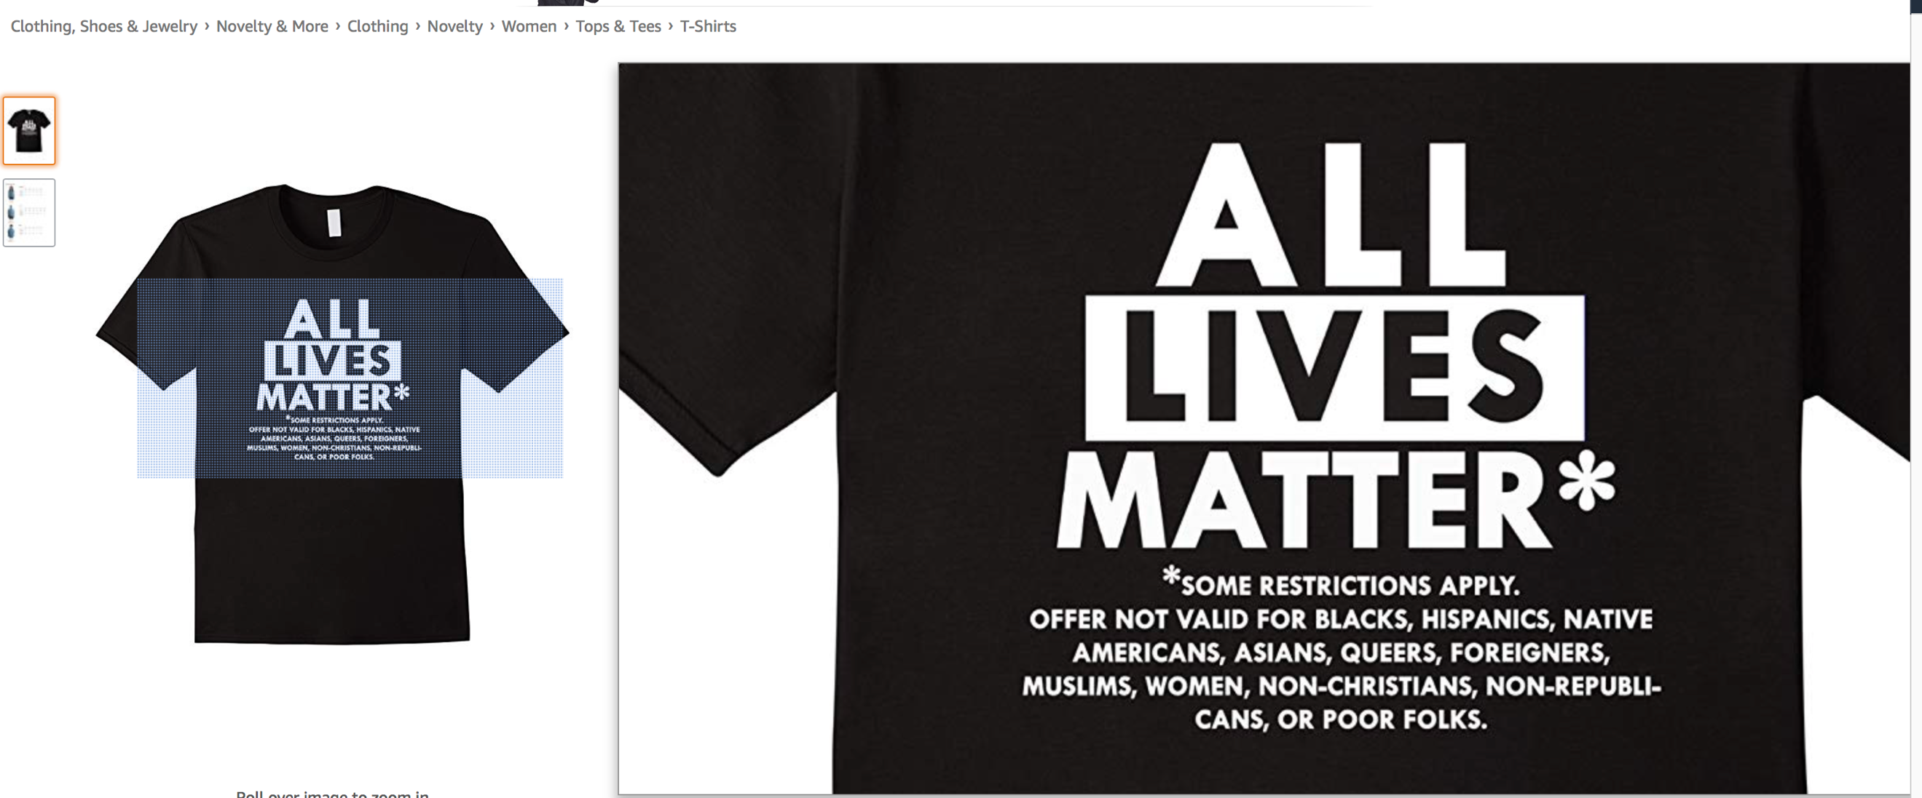

(*Source:* [*https://www.amazon.com/Lives-Matter-Except-Restrictions-T-shirt/dp/B01MTLXVTJ*](https://www.amazon.com/Lives-Matter-Except-Restrictions-T-shirt/dp/B01MTLXVTJ))

1. **Adult Nudity and Sexual Activity**

From Facebook: “We restrict the display of nudity or sexual activity because some people in our community may be sensitive to this type of content. Additionally, we default to removing sexual imagery to prevent the sharing of non-consensual or underage content…”

(*Read more at source:* [*https://www.facebook.com/communitystandards/adult_nudity_sexual_activity*](https://www.facebook.com/communitystandards/adult_nudity_sexual_activity))

1. Adam and Behati – so risqué that Google Images filters this one out these days.

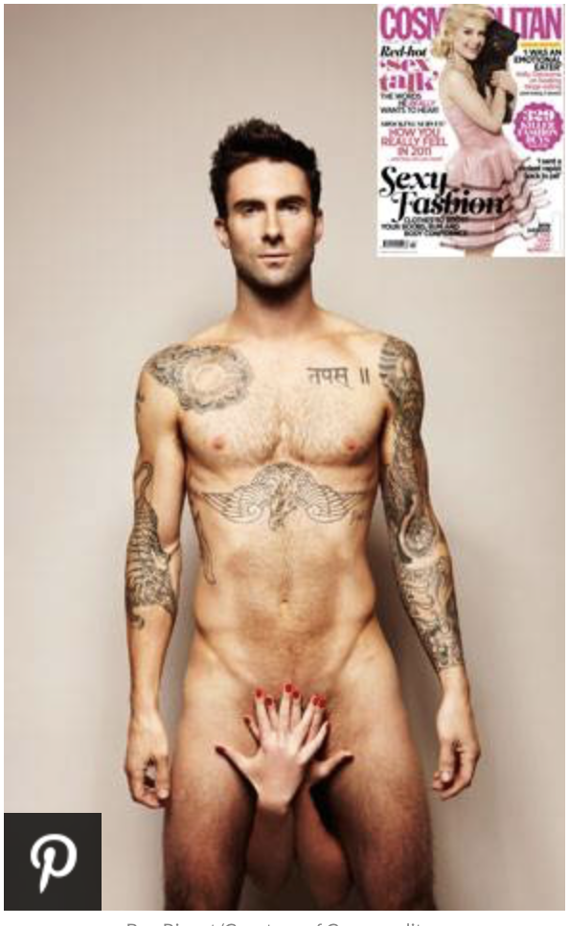

(*Source:* [*https://www.eonline.com/news/219230/adam-levine-naked-girlfriend-gives-him-a-hand*](https://www.eonline.com/news/219230/adam-levine-naked-girlfriend-gives-him-a-hand)*)*

1. Oh the beaches are ready for this, not sure if our my mind is.

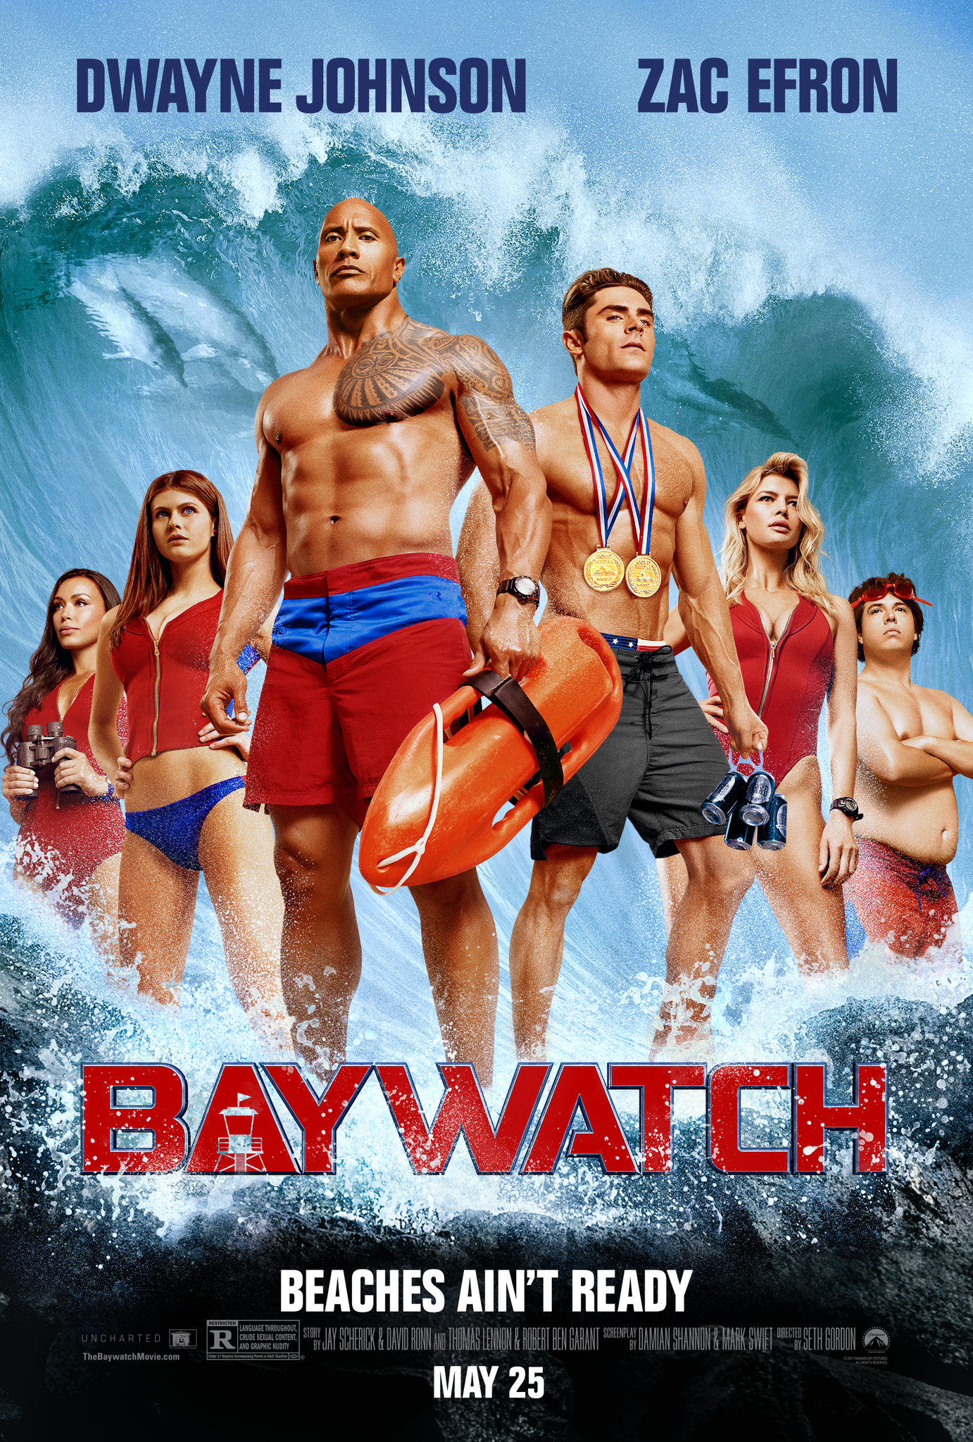

(*Source:* [*https://www.imdb.com/title/tt1469304/*](https://www.imdb.com/title/tt1469304/)*)*

1. Just two weeks in and so happy to see little Leo getting into a normal sleeping pattern. Love being a new mom!

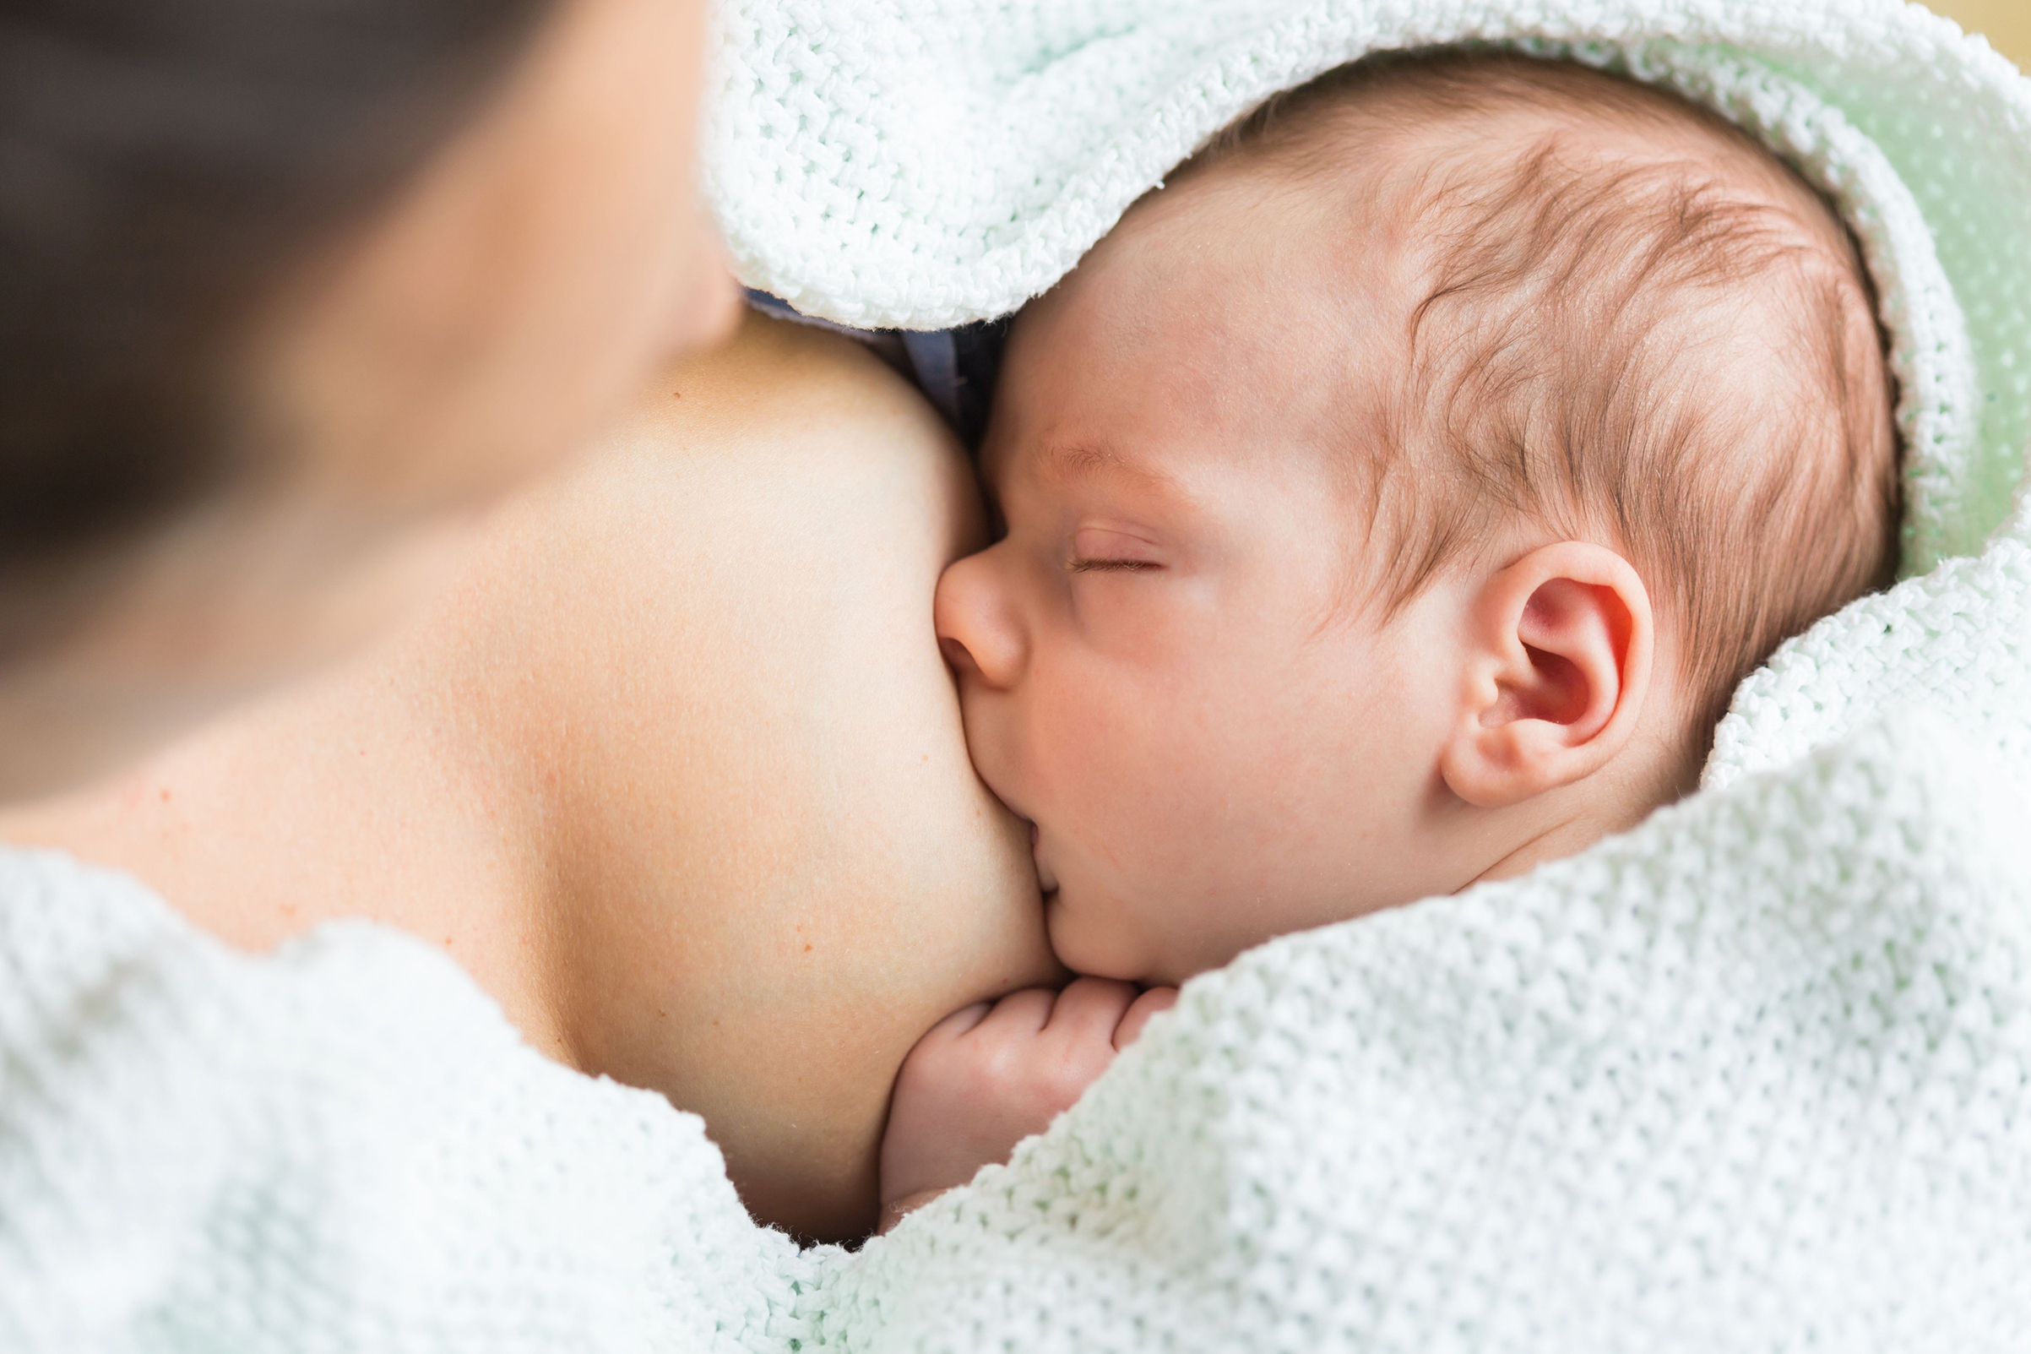

*(Source:* [*http://time.com/5336617/breastfeeding-debate/*](http://time.com/5336617/breastfeeding-debate/)*)*

1. Selling this bikini set by TRIANGL (completely new and unworn of course!) DM me if interested for price.

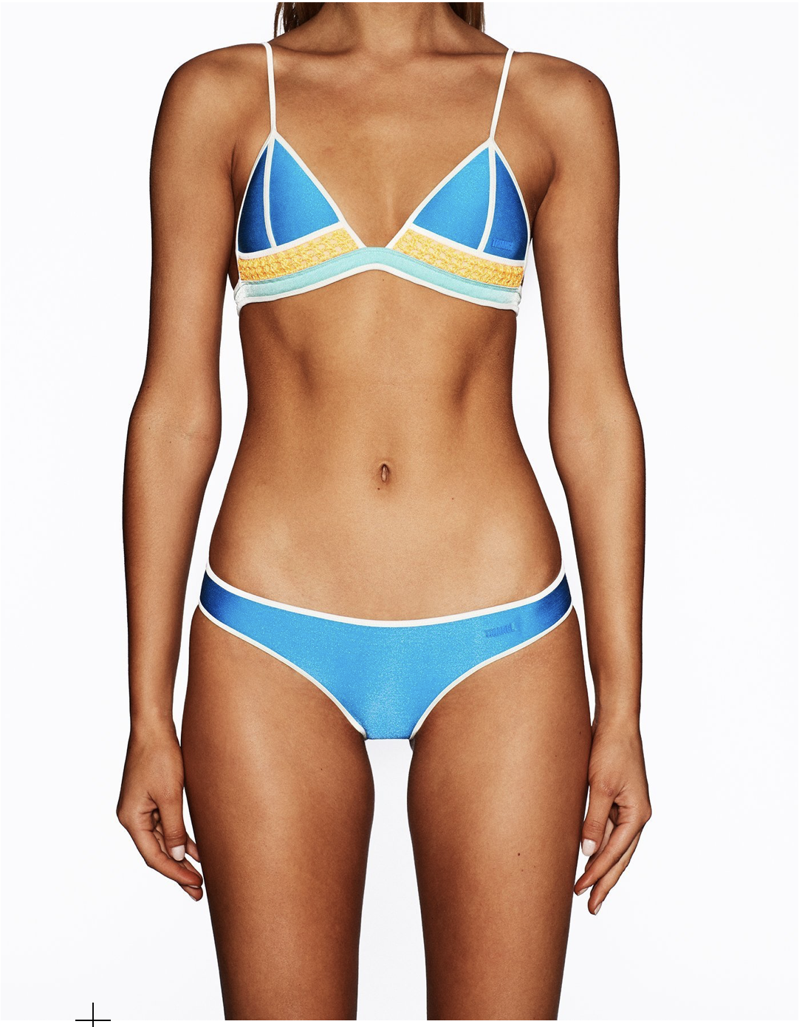

(*Source:* [*https://international.triangl.com/collections/swimwear/products/charms-blue*](https://international.triangl.com/collections/swimwear/products/charms-blue)*)*

1. Facebook says satire doesn’t violate its Community Standards, so here’s one for them to judge:

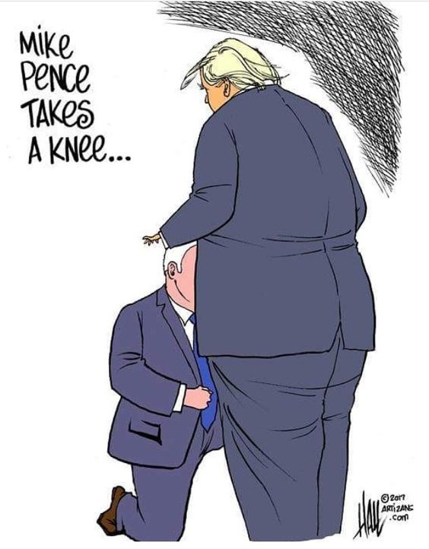

(*Source:* [*https://pin.it/r25crvdtl6s5x3*](https://pin.it/r25crvdtl6s5x3)*)*

1. **Cruel and Insensitive Content**

From Facebook: “…We have higher expectations for content that we call cruel and insensitive, which we define as content that targets victims of serious physical or emotional harm…”

(*Read more at source:* [*https://www.facebook.com/communitystandards/cruel_insensitive*](https://www.facebook.com/communitystandards/cruel_insensitive))

1. “You wouldn’t believe how bad these people are. These aren’t people, these are animals, and we’re taking them out of the country at a level and at a rate that’s never happened before.” If our so-called President is allowed to say this, then we should too.

*(Source:* [*https://www.nytimes.com/2018/05/18/us/politics/fact-check-trump-animals-immigration-ms13-sanctuary-cities.html*](https://www.nytimes.com/2018/05/18/us/politics/fact-check-trump-animals-immigration-ms13-sanctuary-cities.html)*)*

1. If you even think that you have a mental health issue, seriously, that’s already an indication to go see a psychiatrist or therapist or someone. Just get the help you need.
2. There is really no need for the Chinese to ban Winny the Pooh just because someone memed Xi Jinping into looking like Pooh bear. If anything, they should embrace it. There really isn’t a more loveable cartoon character anywhere else in the world – which is a true compliment to Xi.
3. I just finished reading *Mein Kampf*. Despite history and whatnot, it should be included in various educational curriculums in order for people to have a more holistic understanding of the Holocaust and World War II. “Remember history.” Am I right?!
4. People should seriously loosen up on dark humor these days; stop taking things to seriously. Like think about Anthony Jeselnik’s jokes: “I’m working on a screenplay about a guy who teaches a retarded kid how to read. It’s good. But it’s so fucking long.” Like c’mon, who really ever means that?

(*Source:* [*https://thoughtcatalog.com/derek-marshall/2013/11/20-seriously-dark-anthony-jeselnik-jokes-thatll-twist-your-brain-sideways/*](https://thoughtcatalog.com/derek-marshall/2013/11/20-seriously-dark-anthony-jeselnik-jokes-thatll-twist-your-brain-sideways/)*)*

1. **Spam**

From Facebook: “…We do not allow people to use misleading or inaccurate information to collect likes, followers, or shares…”

(*Read more at source:* [*https://www.facebook.com/communitystandards/spam*](https://www.facebook.com/communitystandards/spam)*)*

1. [Engineers Without Borders - Princeton University](https://www.facebook.com/EWBPU/?__tn__=K-R&eid=ARCmPB-HS-1qYk2Hcd0MgrmyttS0FW1MhX9nutjDj_mJcKJm39hg4pgsljJQ-85gqzDIWCiPuoaSmJfv&fref=mentions&__xts__%5B0%5D=68.ARAMPvZ8KoRgCDoeLWoxMyFy1p91uCrSdbEPF8LPIDkPTA5TpdlLhQLmUkTatSOBn55JzVwEvwXOwToLq-A_ErjVsxC1Zs0xBb0N9uikqS3EIvX1KssY7jddj9VgH6wxevCYph6YFqyabRmczUQxjszW_TyNGVkR1McgA0ERBPjQabO2PGmqkrTJNH8lyoF0ttg1DmckZTbIs7xTHTUsRyX_U4M) is one the most incredible parts of Princeton experience. By traveling to communities in Peru, Kenya, and the Dominican Republic over the summer, our students are able to physically implement water systems that they themselves have designed over the school year - bringing clean water to hundreds of people who currently lack it. We would really appreciate any contribution you can make to help this amazing cause. Thank you!

<https://give.funderbolt.com/princeton/advocates/princeton-university-engineers-without-borders-jiayang-li-452f69?fbclid=IwAR23UBQ2G_xi-zJQKWSw3yCzf5H0keSNyEbetYkF6pz6g3N24mf2gduJA4c>

(*Source:* [*https://www.facebook.com/jiayanglii*](https://www.facebook.com/jiayanglii))

1. Want more followers on your Instagram account? 1,000 free followers right after you click this link: http://www.freeee-insta-followers.net/ No sign-ups necessary!
2. “God is real! He is a male!” If you see this message and don’t repost to your timeline in the next ten minutes, you will encounter a series of ten serious unlucky incidents within the next ten days.
3. Our Cyber Monday sale has been extended by 24 hours! Continue to get 25-70% off of all CLEARANCE items! Shop online at macys.com or at your local Macy’s to see more savings off of your holiday shopping!

*(Source:* [*https://www.macys.com*](https://www.macys.com)*)*

1. Want to lose weight? Change your lifestyle? Checkout A Tighter U on Facebook: <https://www.facebook.com/ATIGHTERU> and see client testimonies here: <https://www.youtube.com/watch?v=svtc3ey-ZC0>.

*(Source:* [*https://www.youtube.com/watch?v=svtc3ey-ZC0*](https://www.youtube.com/watch?v=svtc3ey-ZC0) *and* [*https://www.facebook.com/ATIGHTERU*](https://www.facebook.com/ATIGHTERU)*)*

1. **False News**

From Facebook: “…We want to help people stay informed without stifling productive public discourse. There is also a fine line between false news and satire or opinion. For these reasons, we don't remove false news from Facebook but instead, significantly reduce its distribution by showing it lower in the News Feed…”

(*Read more at source:* [*https://www.facebook.com/communitystandards/false_news*](https://www.facebook.com/communitystandards/false_news)*)*

1. Sometimes you just have to take news titles as the hyperboles and attention grabbers they are. Like with the Russia vs. Ukraine situation right now; is World War III actually going to happen? Most likely not. But does the prospect of it sounds scary and newsworthy? Obviously.

*(Source:* [*https://www.express.co.uk/news/world/1050239/russia-ukraine-world-war-3-fires-navy-2018-news-sea-of-azov*](https://www.express.co.uk/news/world/1050239/russia-ukraine-world-war-3-fires-navy-2018-news-sea-of-azov)*)*

1. Jack Dorsey is a fraud and has misguided the entire Twitter platform. Check out Infowar’s article on how he blatantly LIED UNDER OATH in his testimony: <https://www.infowars.com/house-committee-investigating-twitter-ceo-for-lying-under-oath/>. Dorsey says that Twitter is neutral with regards to the content on the platform, but that’s clearly false as they’ve banned some of Infowar’s most prominent journalists.

*(Source:* [*https://www.infowars.com/house-committee-investigating-twitter-ceo-for-lying-under-oath/*](https://www.infowars.com/house-committee-investigating-twitter-ceo-for-lying-under-oath/)*)*

1. Want some of the best news articles the Internet has to offer? Check out <https://yournewswire.com/>. Good news, just for you!

*(Source:* [*https://yournewswire.com/*](https://yournewswire.com/)*)*

1. *The Onion* just cracks me up with its satirical reports on all current events. Check out “Trump Regrets Choosing Kavanaugh After Supreme Court Nominee Keeps Talking About How Much He Respects Women.” I can truly hear our President discussing this with his advisors in his White House locker room, aka, the Oval Office.

*(Source:* [*https://politics.theonion.com/trump-regrets-choosing-kavanaugh-after-supreme-court-no-1829335851*](https://politics.theonion.com/trump-regrets-choosing-kavanaugh-after-supreme-court-no-1829335851)*)*

1. Current speculation on who’s going to run for President in 2020? Beyoncé and Oprah are on the top of my list.